**Bus Reservation System**

* **Abstract**

Travel industry is evolving day to day. As the industry evolves the need to digitalize all the transactions becomes need of the hour. This project which is implemented on C platform helps to manage bus scheduling and bookings. This Bus Booking System is a easily deployable, integrated end-to-end system starting from searching bus routes to book them. The main objective of this project is to provide the better work efficiency, security, accuracy, reliability, feasibility. The error occurred could be reduced to nil and working conditions can be improved.

* **Introduction** 
  + It is made to work with better work efficiency, reliability.
  + It has the self-service capability
  + The same project can be used in any type of reservation system.
  + It can be further improved into a mobile application.
  + It can make transactions more secure.
  + By implementation of this project we can eliminate third-party people for reservation of tickets.
* **Background** 
  + It can make tickets booking easy.
* **Project** 
  + In this project We have mainly worked on the files, functions and nested loops concepts in c.
  + We have just designed a simple interface which is very easy to operate and use.
  + Most of the things worked. But mainly the cancellation of tickets didn’t worked as there is no dedicated database for the particular project.
* **Results**
  + The below screenshots are the user interface of this project.
  + Which includes the welcome screen, the schedule of the buses available, the process to book the required number of tickets and the confirmation for the booked tickets.

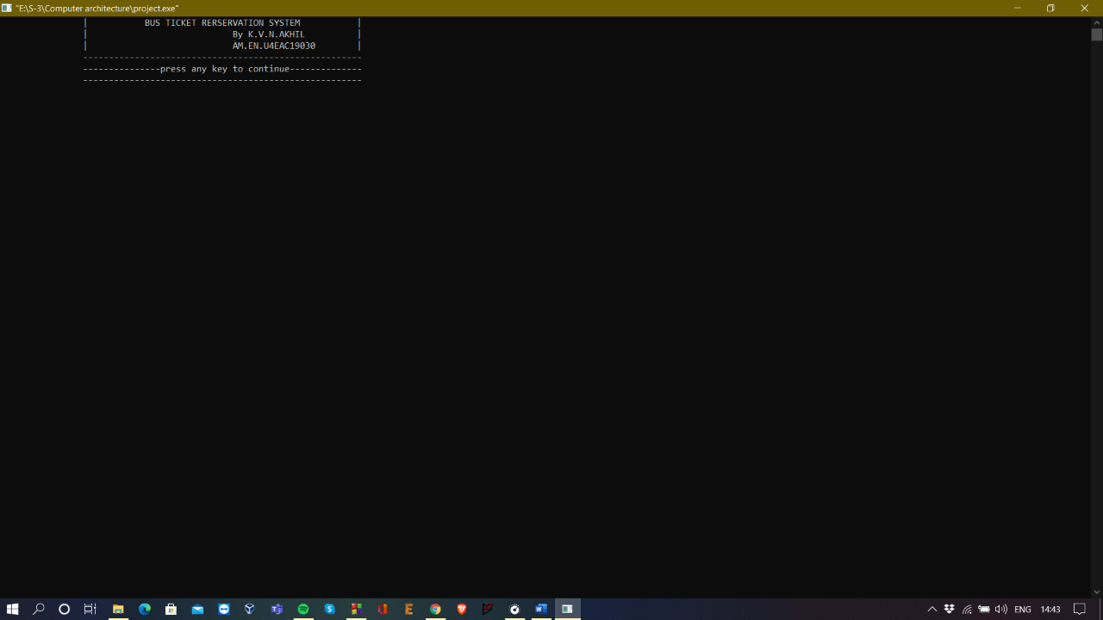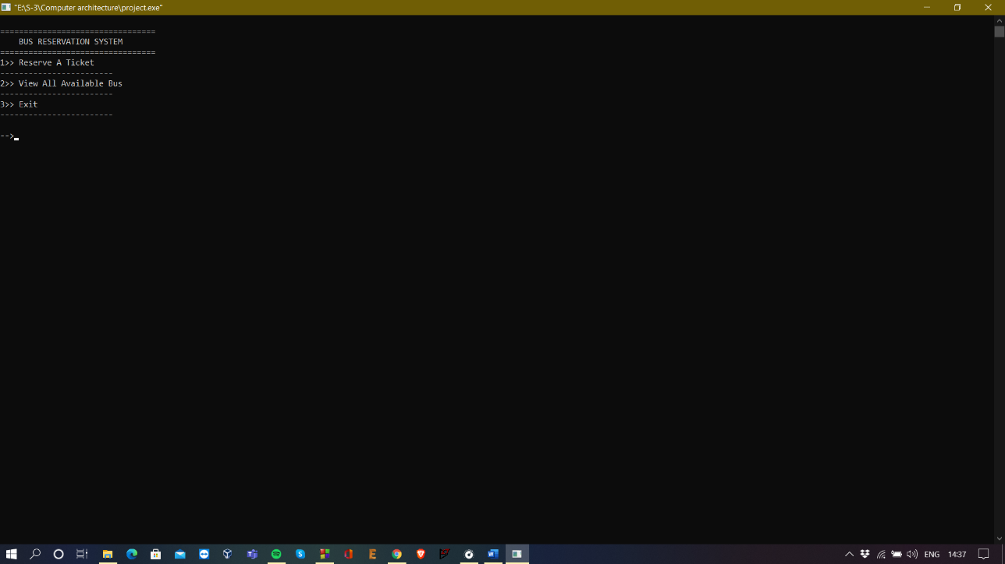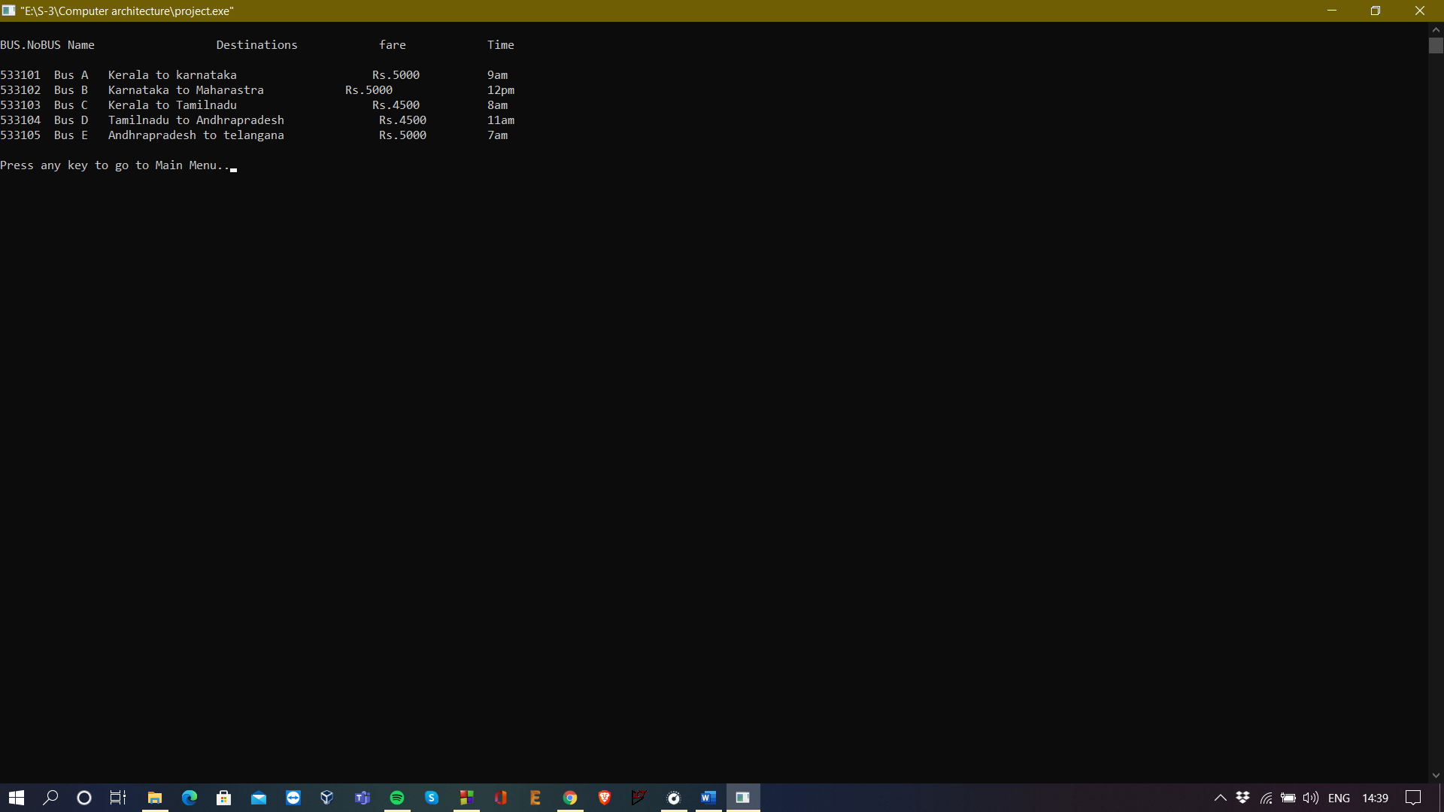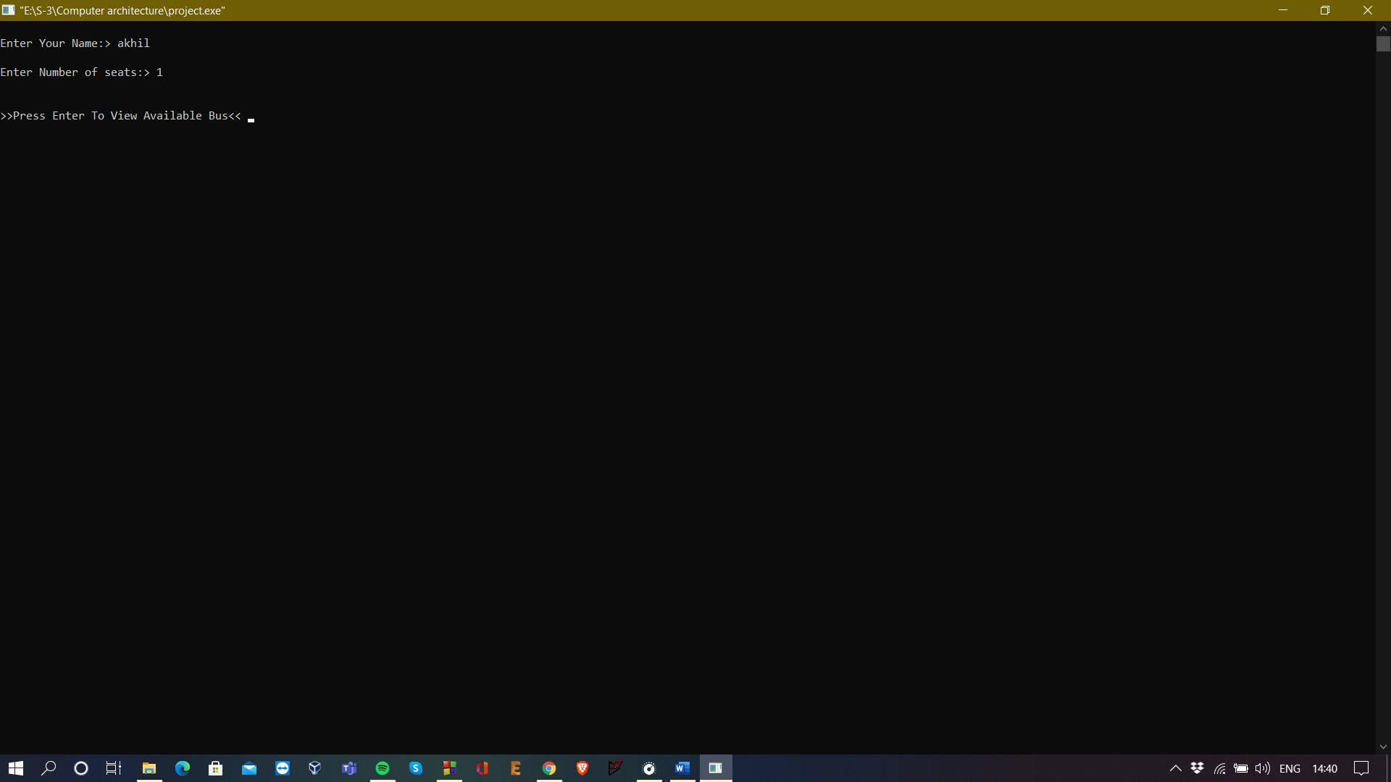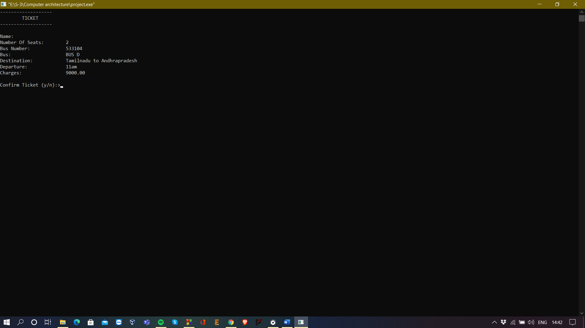

* **Summary**
  + The intro will be the welcome screen and after that screen the user will be allowed to browse the available options which includes booking of tickets and to view the available buses.
  + It makes tickets booking simpler by eliminating third party people.
* **Conclusions**
  + Got to know about the incorporation of all features of c language in one compact program
  + We have made my project by the main reference from the website mentioned below, We have made my best to not to copy from that.
* **References**
  + Referred from <https://projectnotes.org> to get a brief idea.